Overview of Water Related Issues in OIC Member Countries

Introduction
Water is essential element for life. Water resources are the sources of fresh water that virtual for human and natural activities. Uses of water include agricultural, industrial, domestic, recreational and environmental activities. Fresh water is only 2.5% of the total water on earth and over two thirds of it is frozen. Small fraction is flows as surface water or in the air and the rest is accumulated as ground water.
Increase of water demand, the supply for clean, fresh water is in steady decrease. Moreover, water scarcity is emerging as a major development challenge for many countries. While in some countries water availability is a key concern, other countries with expanding urban settlements, industrial sectors, and commercialized agriculture, water quality is a major concern.
Although the nature and severity of water problems varies among countries, one aspect is common to most of them, which is that the water scarcity, whether qualitative, quantitative, or both; originates more from inefficient utilization and poor management.
Climate change has rising significant effects on water resources depletion and other related-water disasters. Many OIC Countries has already witnessed frequent droughts and floods due to global warming.
OIC Member Countries as a whole has a big challenge in tackling the causes and consequences of water scarcity. In the following pages, the current condition of water resources is stated, the general challenges related to water issues in OIC Member Countries are discussed, and finally a set of proposed mitigation policies and their implementation instruments are suggested.

Water Resources in OIC Countries
Water resources are distinguished as renewable and non-renewable water resources. Renewable water resources means the resources that regenerated, by precipitation, faster than its consumption, while non-renewable or fossil water, which is accumulated in millions of years deeply underground and overexploiting it cannot be recovered easily. Internal renewable water resources is that part of the water resources generated from endogenous precipitation. It is computed by adding up surface runoff and groundwater recharge occurring inside the countries' borders. Special care is taken to avoid double counting of their common part. Total renewable water resources refers to the sum of internal renewable water resources and incoming flow originating outside the countries' borders, which called the external renewable water resources. The mentioned indicators have been compiled or estimated for each country.
The total renewable water resources in OIC Member Countries is 8033.32 km³ in 2007, which represents 9.86% of the world total renewable resources. The total internal resources is approximately 76.2% of the total renewable resources of OIC Member Countries. The total amount of surface water resources, which means rivers and natural ponds, represents around 95% of total internal water.
Figure 1: Total Renewable Internal and External Water Resources in OIC Member Countries
. 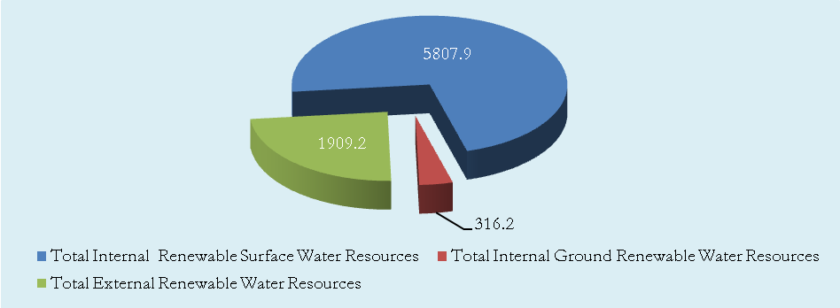
OIC Member Countries have a large range of climates, which generates a variety of hydrological regimes. Some parts like East Asia and Bangladesh has the highest precipitation, while other parts like Middle East and North Africa (MENA) has a very arid climate with closed hydrologic systems. The highest average precipitation in depth is 2,875mm/yr in Malaysia, while the lowest is 51mm/yr in Egypt.
Figure 2: The Highest and Lowest Average Precipitation in Depth, 2007 (mm/yr)
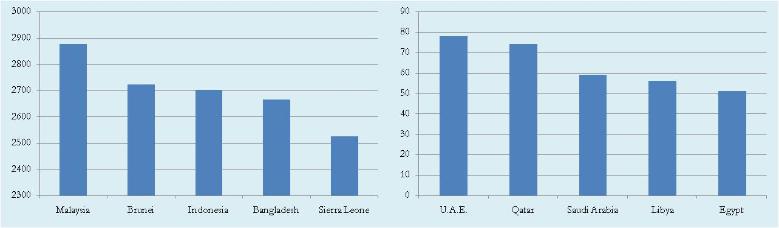

As a result, the region shows a very uneven distribution of its water resources and of its water use conditions. East Asia (Brunei, Indonesia and Malaysia) has 42% of total renewable water resources, which is the highest share; while Middle East and North Africa, which represents 19 countries, shares the minimum of 4.4%. Sub Saharan Africa shares 23.3%, South Asia has 18%, Europe and Central Asia and South America represent 6.4% and 4.5% respectively.
Figure 4: Total Renewable Water Resources in OIC Regions, 2007 (km³)
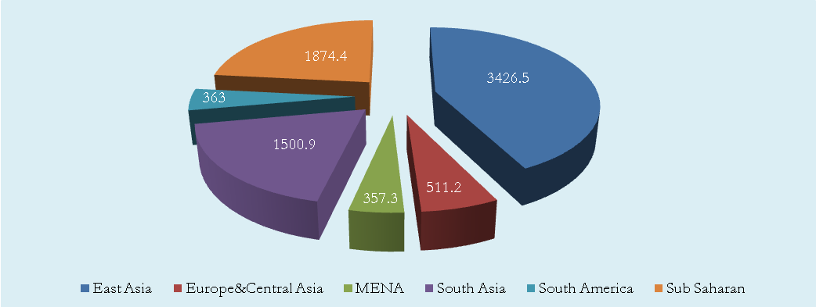
For country level, Indonesia and Bangladesh has the highest total amount of renewable resources, which is over than 1,000km³/yr, while Kuwait and Maldives have the lowest amount with 0.02 and 0.03 km³/yr respectively.

Figure 5: Top 10 Highest Total Renewable Water Resources in OIC Regions, 2007 (km³)
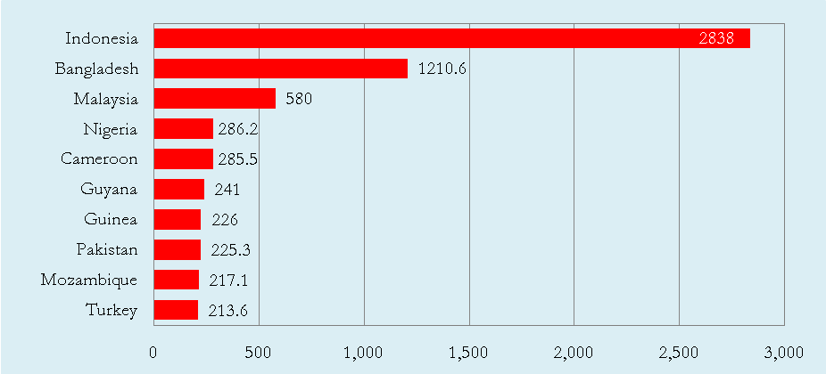
Since Indonesia is an inland, its total renewable resources are internal resources. Malaysia is the second largest in its internal renewable resources.
Figure 6: Top 10 Highest Total Internal Renewable Water Resources in OIC Regions, 2007 (km³)
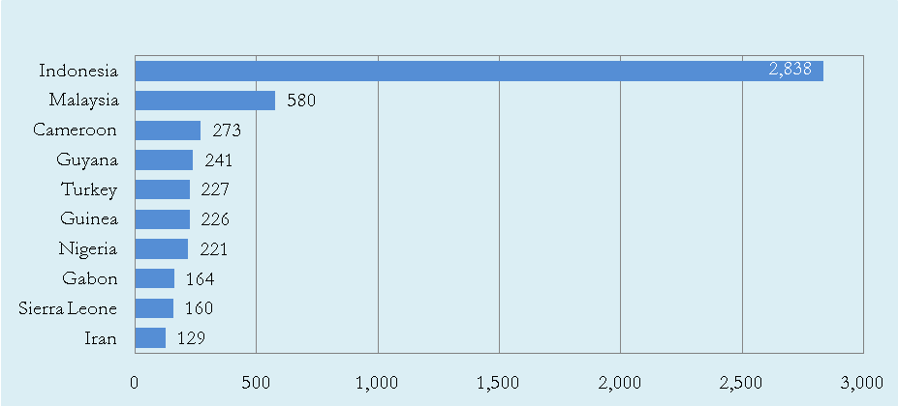
The top 10 highest list for external renewable resources is quite different to the last two figures. Bangladesh has the highest external renewable water resources with 1105 km³, which indicate its high dependency on water flowing outside its borders.

Figure 7: Top 10 Highest Total External Renewable Water Resources in OIC Regions, 2007 (km³)
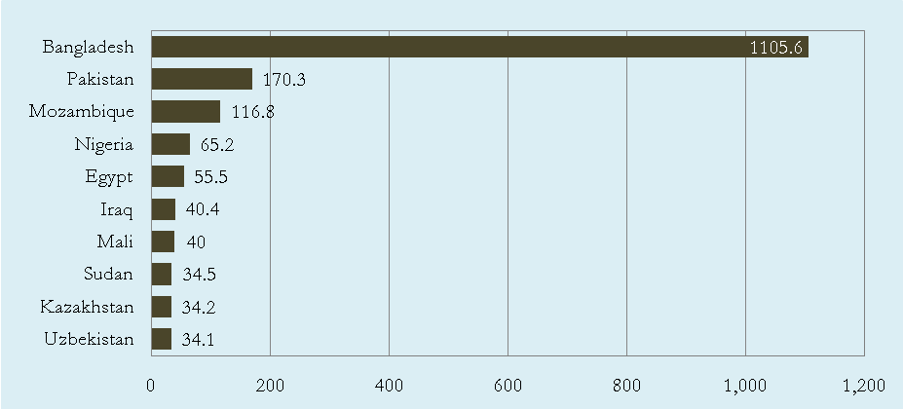
Furthermore, many countries in the region depend to a large extent for their renewable water resources on water flows originating outside their borders. This is measured with the indicator Dependency Ratio, which means the percentage of external renewable water to the total renewable water.
Kuwait and Bahrain are the first and fourth highest ratio of 100% and 96.55% respectively. Six countries depend for over 90% for their renewable water resources on other countries: Egypt (Nile River), Mauritania (Senegal River), Bangladesh (Ganges River from India) and Turkmenistan (Amu Darya River) for surface water and Kuwait and Bahrain for groundwater (from Saudi Arabia). Syria and Sudan depend for around 76% on upstream countries (mainly the Euphrates from Turkey and the Nile from Ethiopia), but on the other hand they are located upstream from other countries depending on the same rivers (Iraq and Egypt respectively). To a lesser extent, but still over 50% dependent on other countries, are Somalia (Shebelle and Juba Rivers) and Iraq (Euphrates and Tigris Rivers).
Figure 8: OIC Member Countries that has the highest Dependency Rates, 2007
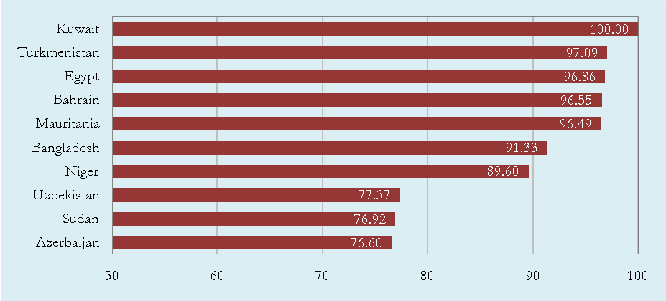
Meanwhile, several countries in the region that have few renewable water resources depend on important non-renewable groundwater basins, partly shared with neighboring countries. By far, in some countries (Saudi Arabia, Libya and the United Arab Emirates), the largest part of the total water withdrawn is fossil water. However, although groundwater reservoirs may allow storage of huge quantities of water, they cannot be considered sustainable in the long term, as the lack of present recharge would result in the slow depletion of the aquifers. Moreover, the water level decline and the resulting increase in the cost of pumping as well as the deterioration of the water quality in some areas may also make the abstraction of fossil water less attractive with time.
Other than Bangladesh, Egypt, and Sudan; the other countries depend on the external water resources of countries within OIC. Therefore, it would make the issue of water resources management among them easier to tackle. Hence, transboundary water cooperation within OIC Member Countries is very essential.
Unfortunately, Bangladesh, which its dependency ratio 91.3% on Ganges River, suffers every year from riverine floods that have disastrous impacts on 25-35% of the country taking lives of hundreds and destroying millions of houses in addition to the huge loss of crops and livestock. It happens as a reason of riverbank overflow of Ganges in Monsoon seasons. The improper embankment-opening from Indian side causes inundation and in hence huge damage in Bangladesh. Consequently, international agreement between the two sides is essential to put an end to this annual disaster.

Water Scarcity
Water scarcity is defined as the imbalance of supply and demand of water. A country or region has a water scarcity when the total amount of renewable water resources is less than 1,700m³ per capita per year. Scarcity is physical in case of unavailability of water resources, economical when available water resources are utilized inefficiently, or both.

Most of OIC Member Countries have limited water resources compare to regions like Europe, America and Oceania. As shown in Figure 1, the total renewable water resources per capita for the OIC Member Countries is 5,622m³/yr, which is quite low compared to regions of Europe, North America, Latin America and Caribbean, Australia and New Zealand and to the world average.

Figure 9: Total Renewable Water Resources per Capita in Regions, 2007 (000m³/yr)

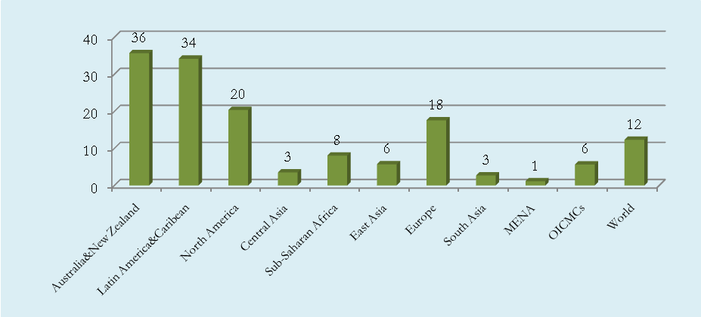

Moreover, the percentage of total renewable water resources withdrawn for anthropogenic use (Domestic, industrial, and agricultural) are relatively high if it is compared to world average and to other regions. In OIC Member Countries, the water withdrawal from renewable resources is approximately 14.09%, while for world average does not exceed 5.58%.

Figure 10: Total Renewable Water Resources and its withdrawal per Capita in OIC and World, 2007 (000m³/yr)

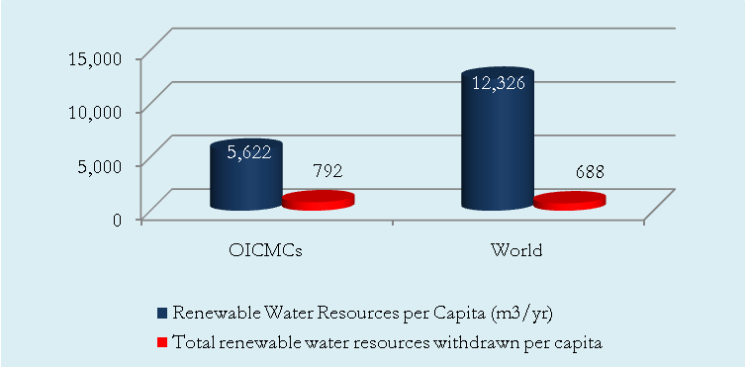

Although the OIC Member Countries are the fourth least in renewable water resources comparing to other region, it has the fourth highest water consumption. North America that has the largest amount of water resources, it withdraws not more than 8.33% of these resources. As for Australia and New Zealand, the second largest, its consumption does not exceed 3.12% from the total resources.

The total withdrawn water resources varies among OIC sub-regions. The lowest percentage of withdrawal is in Sub Saharan Africa, 2.18% and East Asia, 9.2%; while the highest is 74.07% in Middle East and North Africa. This value is also high in South and Central Asia, 25 %and 14% respectively.

Figure 11: Total Renewable Water Resources withdrawal per Capita in Regions, 2007 (000m³/yr)

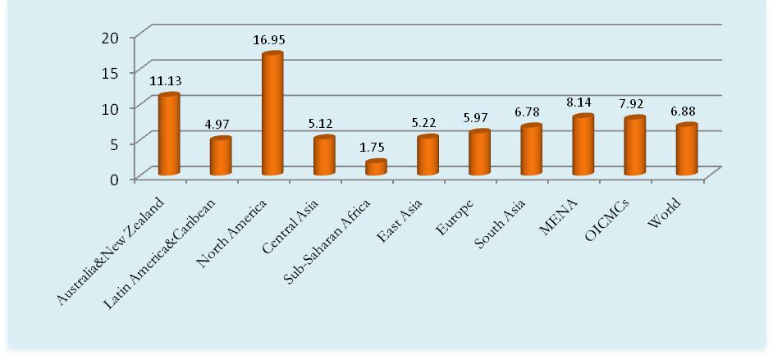
The limited renewable water resources with high percentage of water withdrawal indicate an economical water scarcity. The economical scarcity results from inadequate utilization of water resources such as, overexploitation, water quality deterioration due to lack of waste treatment, water leakages because of deficiency of maintenance
The main reasons of such mal-utilization are the following:
- Scattering of responsibilities and lack of coordination between authorities involved in the management of water resources and lack of integration of the various policies: In many OIC Member Countries, 3-4 ministries are responsible for water issues at the same time. For instance, Ministry of Agriculture, Ministry of Irrigation, Ministry of Construction, and municipalities are sharing responsibilities of water issues, and every ministry has its own policies, which makes it a tough task to have an integrated framework for water management.
- Scarcity of accountability: This occurs when there is absence of a legal framework and transparency between governments and users. In other words, the lack of lax control, inadequate water pricing, and involvement of the users in water resources planning and management will increase carelessness and have misleading approach for sustainable use of water.
- Lack of qualified staff in charge of water management, and lack of financial capacity, which impedes the implementation of the national plans for an integrated management of water resources and water demand. Most of the 57 OIC Member Countries are developing countries and 20 of them are Least Developed Countries (LDCs). Their economic and social development represents a major challenge for themselves and the OIC community as a whole.

Figure 12: Total Renewable Water Resources per capita through years (000m³/yr)
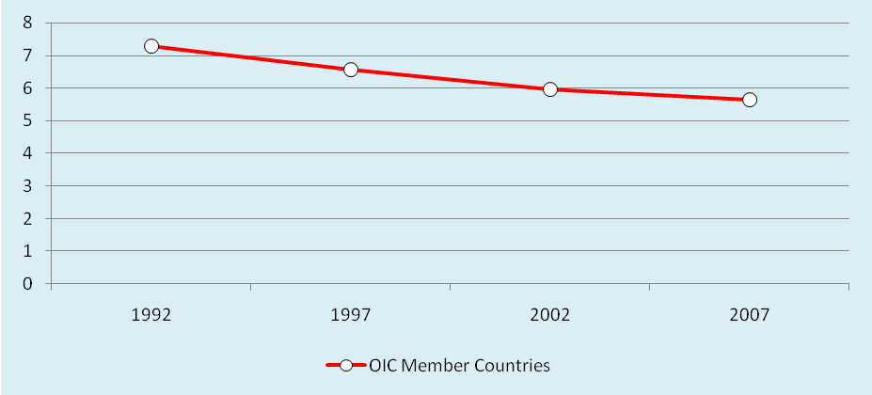

There are also other factors accelerate the scarcity of water and lead to physical scarcity in the OIC Member Countries:
- Increase of demand for anthropogenic activities: The population growth rate in OIC Member Countries is relatively high. The average annual rate is 2%, which is higher than the world average. The rapid boost of population involves a high demand for domestic use, disregarding increase of industrial and agricultural needs. It is estimated that the average total renewable water resources per capita has decreased 22.8% since 1988. Except Albania, Guyana, and Kazakhstan, other countries show a decrease in a range of 11.1%-51.2%. Bahrain and Qatar has the worst decline with 50.9% and 51.2% respectively.

- For developing countries the main source of income, agriculture, is the most water-consuming sector. It accounts for more than 70% of total water demand. Management of irrigation water restricts overexploitation of water resources. Unfortunately, irrigation water efficiency is below 45% in most of OIC Member Countries. The reason for that is the widely use of the old traditional ways of irrigation, the efficient use of water in agriculture is not adequately addressed by the countries of the region where sustainability of the existing irrigation systems is at stake. While surface irrigation is by far the most widely used system in irrigation, practiced on 87.6% of the total full and partial control irrigation area, the most water-saving system through micro-irrigation techniques is only practiced on a mere 1.4% of the total irrigation area.

Water Scarcity in the Middle East and North Africa
In addition to economical scarcity the Middle East and North Africa suffers real physical water scarcity since the total renewable water is less than 1,700m³/yr per capita, which is also the lowest among regions. This indicator varies among this region’s countries. Some of them suffer from absolute scarcity with total renewable resources less than 500 m³/yr like Gulf Countries and Jordan. Moreover, the withdrawn of these resources is as high as 74.07%, which indicates considerable economical scarcity for the region.

Figure 13: Total Renewable Water Resources per Capita in the Middle East and North Africa
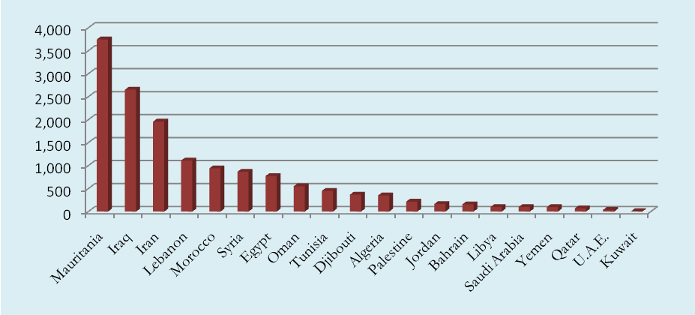
Another challenge facing this region is the increase of demand, which cause diminishing of renewable resources. Statistics show a decrease of total renewable water per capita with average 27% since 1988. This percentage reaches 50.2 in UAE and Jordan. Therefore, it is predicted that 10-20% of non-renewable water resources will be exploited in the Middle East for the coming two decades. With the limited water resources, it would be hard to keep up with the basic needs for water in the future.

Access to Improved Water and Sanitation
Access to improved drinking water and sanitation are the basic rights for inhabitants in order to has a hygiene and safe sort of life. Access to improved water means the percentage of population with reasonable access to an adequate amount of water from a household connection, public standpipe, protected well, or spring or rainwater collection. Access to sanitation facilities is defined as the percentage of population with access to at least excreta disposal facilities that can effectively prevent human, animal, and insect contact with excreta.

Although access to improved water and sanitation has been improving in OIC Members Countries to reach 76.19% and 56.10% for the last two decades, it is yet below the world average since these indicators are very low in OIC Least Developed Countries.

Figure 14: Population with Access to Improved Water and Sanitation (%)
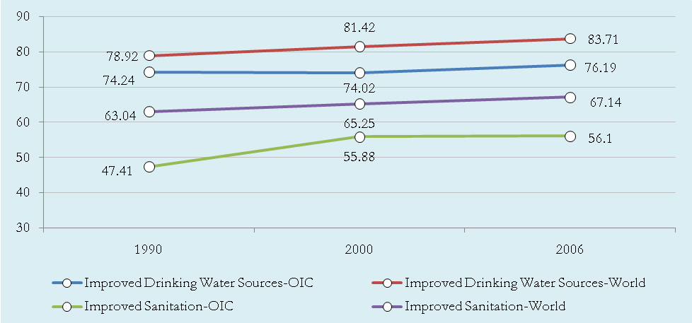

Lebanon, Qatar, and United Arab Emirates have 100% access for improved water. Thirteen countries have more than 90% access. On the other hand, six countries have less than 50% access. There are Afghanistan, Somalia, Niger, Nigeria, Chad, and Mozambique.
Figure the 15: Highest and Lowest Access to Improved Water in OIC Members Countries, 2006
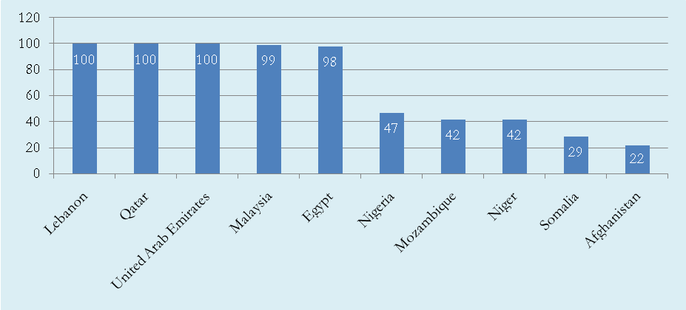

Nevertheless, the access for sanitation is low behind. While there are 11 countries have more than 90% access for sanitation, 22 countries have less than 50%. All these countries are Least Developed Countries. 16 of them are Sub Saharan African.
Figure the 16: Lowest Access to Sanitation in OIC Members Countries, 2006
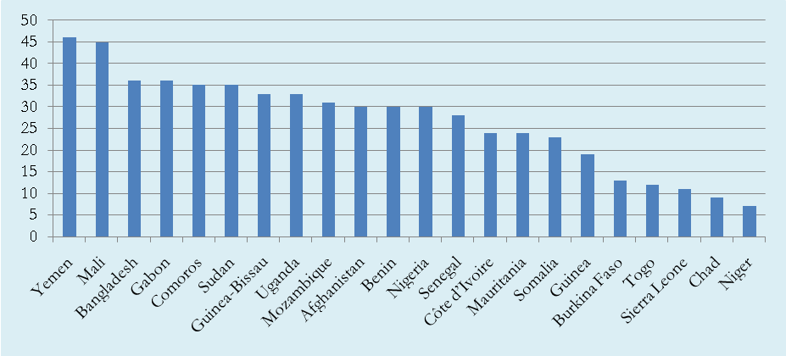
Unfortunately, in Sub-Saharan Countries still millions of people affected by water-borne diseases occur due to lack of water and sanitation access and inadequate management of natural pounds and swamps. In Niger and Chad , it is as low as 7% and 9% respectively. The latest data of FAO shows the number of patients was around 3 million in Burkina Faso, Cote d’Ivoire and Mauritania in year 2007. According to WHO, the number of patients recorded in hospitals as Malaria reaches 50% in Mozambique and Uganda.
In Bangladesh. 28-35millions of people use groundwater from illegal wells that contaminated naturally with high levels of inorganic Arsenic. The elevated level of Arsenic causes severe dermatologic diseases. More than 1.5million cases of skin lesions are reported every year. Moreover, cancer and some heart diseases are suspected to be aggravated by Arsenic.
Providing safe water supply and sufficient sanitation facilities prevents significantly these diseases. It is estimated that basic sanitation can reduce Schistosomiasis and Diarrhea morbidity 77% and 35% respectively.

Effects of Climate Change on Water Resources
There are many serious consequences of the climate change and global warming on earth. These impacts severely will and have already been affecting the globe including our OIC member countries. Other than water scarcity, some regions faced frequent natural disasters during the last couple of years. For instance, the current drought in Middle East, Turkey; yearly floods in Bangladesh, melting of glacises causing flood in Pakistan, and heavy rain in Oman two years ago.
Climate change is predicted to reduce water availability severely by up to 60% in the coming century. Water shortages are likely to worsen and become critical. Reductions in water availability are likely to have drastic effects on agriculture, economic diversity and productivity, lead to a loss in GDP, displace large numbers of people, and lead to food shortages. The change of climate has already witnessed. Precipitation has decreased by 4-27% with significant spatial and seasonal variation.

Central Asian Region is a handed example for regions that suffer from negative impact of climate change. It experienced a severe drought in the last few years. The drought in 2008 causes decrease in the production of main crops. It is estimated the decline of wheat yield ranging from 3% in Uzbekistan to 25% in Tajikistan and Turkmenistan.
Furthermore, Central Asian Countries rely heavily on hydropower stations for generating electricity. Decrease of water levels lead to electricity shortage. Electric power generation during the first three quarters of 2008 was down 17% in the Kyrgyz Republic and 13% in Tajikistan. In addition, some large-scale power stations would be out of function. This would deprive millions of people of heat and electricity in the cold winters. Moreover, unsustainable utilization of water and lack of transboundary water cooperation among these countries accelerates the problem, especially in downstream countries (Kyrgyzstan and Tajikistan).

Policies and Mitigation Strategies
Addressing water scarcity requires an inter-sectoral and multidisciplinary approach to managing water resources in order to maximize economic and social welfare in an equitable manner without compromising the sustainability of vital ecosystems. Integration across sectors is needed. This integration needs to take into account development, supply, use and demand, and to place the emphasis on people, their livelihood and the ecosystems that sustain them. The integrated policy has three levels:
• At OIC level, member countries need to seek enhancing cooperation in dealing with transboundary water management issues, focusing on negotiations and dialogue and on the quest to optimize the overall societal benefits of water.
• At national level, policies and governance need adapting in order to better account for increased scarcity and address competing uses in a fair and equitable way. The institutional integration of water policies and increased stakeholder involvement in decision-making processes are paramount to this process, focusing on optimal water pricing and public-private partnership.
• At local level, better management practices are needed in all fields, leading to increased productivity and sustainability in water use and to improved sectoral integration in the management of water resources, beside increase awareness and encourage the habit of water and food conservation.

Regarding the issue of climate change, efforts to curb greenhouse gas emissions need to be prioritized and enhanced with urgency in order to minimize future climate change and its impacts. Extensive adaptation measures need also to be adopted, including water conservation, increasing water use efficiency. Drought contingency plans need to be developed and worked into planning and legislation at all levels, including peace agreements. Cooperative efforts need to be undertaken within and among OIC Member Countries to tackle the causes and effects of climate change and adapt to future climates with an approach that utilizes the challenge as a reason for cooperation rather than a trigger for conflict.

Since more than water withdrawal used for agriculture, 1) promoting and providing modern techniques and water-saving technologies of irrigation, 2) shifting from surface irrigation system to pressurized irrigation, 3) introducing new crops that demand less and the emphasize on dry farming, 4) appropriate water tariffs; will contribute to the goal of effective utilization of limited water resources.

In order to implement the aforementioned policies set of instruments are required, as following:

- Create two main task forces for climate change and water scarcity issues with the following responsibilities:
- Deliver a comprehensive overview of the extent and impacts of water scarcity and climate change in OIC.
- Prior indicators could be set-up and agreed by the OIC in order to ensure the collection of relevant and comparable data at national level and therefore reflect the true situation at river basin level.
- The impacts of climate change on the future evolution and extent of water scarcity and natural disasters need to be further assessed,
- The economic, social and environmental impacts of the water scarcity and climate change need to be better quantified.
- Start working towards the establishment of an effective OIC information system for water resources and metrology by discussing the steps and (financial and human) resources needed.

- Create a Climate Change Adaptation Fund as one of OIC-IDB Funds for:
- Capacity building to adapt to climate change and risk management of natural disasters (floods and droughts) resulting from global warming.
- Build a database of experiences of OIC Member Countries in disaster management.
- Develop disaster communication strategies to reduce the risk of climate change.
- Vulnerability mapping to identify areas most prone to the risks of climate change.
- Carry out projects for the hotspot regions like Bangladesh and Sub-Sahara countries.

